**Collective Intelligence**

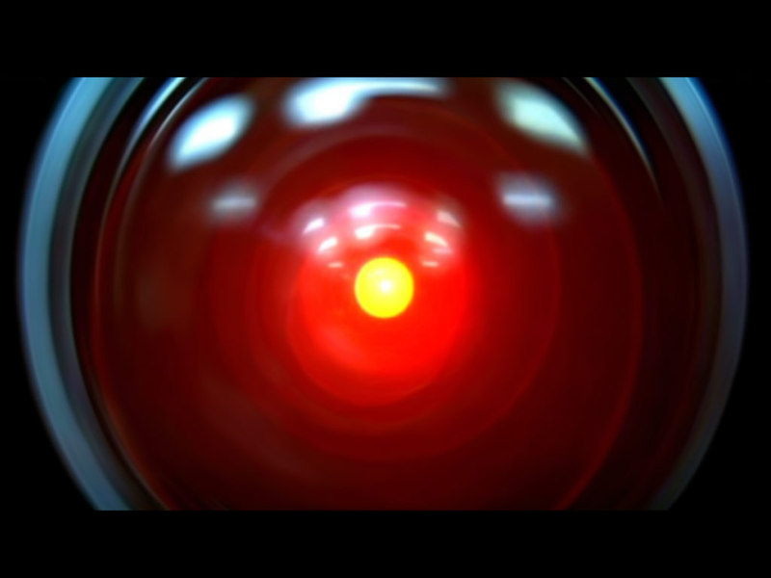

**Contents**

**General Research** **2**

**Math, Probability** **3**

**Machine Learning (* means how technical the information is)** **4**

**Reinforcement Learning** **6**

**Programming** **7**

# **General Research**

1. **Tools for research**
   1. [LibGen - Free scientific books](https://www.google.com/search?q=libgen&oq=libgen&aqs=chrome..69i57j0l4j69i65.3014j0j4&sourceid=chrome&ie=UTF-8)
   2. [Sci-Hub - Free scientific papers](https://whereisscihub.now.sh/)
   3. [Auto Sci-Hub - Extension for chrome](https://chrome.google.com/webstore/detail/auto-sci-hub/nlogbpfgpkffmombiknfdoogphkimmmd?hl=en)
   4. [arXiv - Free storage of preprint/printed papers](https://arxiv.org/)
   5. [Google Scholar - Search engine for scientific papers](https://scholar.google.com/)
   6. [Papers with Code - Collection of papers that have code](https://paperswithcode.com/)
   7. [F1000 - Paper reference manager](https://f1000workspace.com/)
2. **Courses/Tutorials**
   1. [Coursera](https://www.coursera.org/)
   2. MIT OpenCourseWare - [Website](https://ocw.mit.edu/index.htm), [Youtube channel](https://www.youtube.com/user/MIT/featured)
   3. [edX - Free online courses from universities](https://www.edx.org/)
   4. Stanford courses
   5. [Khan Academy](https://www.khanacademy.org/)
   6. [Udacity](https://www.udacity.com/)
   7. [Udemy](https://www.udemy.com/)
3. **Practicing Places**
   1. [Driven Data: Data and Competitions](https://www.drivendata.org/)
   2. [Kaggle: Data and Competitions](https://www.kaggle.com/)
   3. [Brilliant - Math related courses, problems](https://brilliant.org/)
   4. [Nice cheat sheet for many topics](https://github.com/FavioVazquez/ds-cheatsheets)
4. **Videos**
   1. [Primer](https://www.youtube.com/channel/UCKzJFdi57J53Vr_BkTfN3uQ) - more about evolution simulations
   2. [SpaceTime](https://www.youtube.com/channel/UC7_gcs09iThXybpVgjHZ_7g/videos) - just in case Astronomy is interesting
   3. [Kurzgesagt](https://www.youtube.com/user/Kurzgesagt/videos) - just in case different Scientific disciplines are interesting

# **Math, Probability**

1. **Books**
   1. A Student's Guide to Bayesian Statistics - Book, [Youtube](https://www.youtube.com/playlist?list=PLwJRxp3blEvZ8AKMXOy0fc0cqT61GsKCG)
   2. [Probabilistic Programming and Bayesian Methods for Hackers](http://camdavidsonpilon.github.io/Probabilistic-Programming-and-Bayesian-Methods-for-Hackers/)
   3. [A First Course in Probability Theory](http://julio.staff.ipb.ac.id/files/2015/02/Ross_8th_ed_English.pdf)
   4. [Probabilistic Systems Analysis and Applied Probability](https://ocw.mit.edu/courses/electrical-engineering-and-computer-science/6-041sc-probabilistic-systems-analysis-and-applied-probability-fall-2013/) - first 2 units are great to get started in probability theory
   5. Statistics
   6. [Introduction to Applied Linear Algebra Vectors, Matrices, and Least Squares by Stephen Boyd, Lieven Vandenberghe](http://vmls-book.stanford.edu/vmls.pdf)
   7. Calculus
2. **Videos**
   1. [3Blue1Brown - Explanation of mathematical concepts](https://www.youtube.com/channel/UCYO_jab_esuFRV4b17AJtAw)
   2. [NumberPhile](https://www.youtube.com/user/numberphile/videos) - Nerdy math channel about numbers
   3. [ComputerPhile](https://www.youtube.com/user/Computerphile/featured) - Little bit less nerdy channel about CS
   4. [Mathologer](https://www.youtube.com/channel/UC1_uAIS3r8Vu6JjXWvastJg) - deep dive into math concepts
3. **Courses/Tutorials**
   1. [MathProfi.ru](http://mathprofi.ru/) - Series of blog posts about how to solve mathematical problems (integration, differentiation etc.)
   2. [Jbstatistics - statistical concepts explained](https://www.jbstatistics.com/)

# **Machine Learning (* means how technical the information is)**

1. **Books** 
   1. [Machine Learning A Probabilistic Perspective by **Kevin P. Murphy**](https://doc.lagout.org/science/Artificial%20Intelligence/Machine%20learning/Machine%20Learning_%20A%20Probabilistic%20Perspective%20%5BMurphy%202012-08-24%5D.pdf) **\*\*\***
   2. [Pattern Recognition and Machine Learning by **Christopher M. Bishop**](http://users.isr.ist.utl.pt/~wurmd/Livros/school/Bishop%20-%20Pattern%20Recognition%20And%20Machine%20Learning%20-%20Springer%20%202006.pdf?fbclid=IwAR2G6IKQg1RfDTcDVEZb3UiWN2dusuFhpRLFU3hkso5DRZKYrzheTqRlWyM) **\*\*\***
   3. [Deep Learning with Python by **Francois Chollet**](http://faculty.neu.edu.cn/yury/AAI/Textbook/Deep%20Learning%20with%20Python.pdf) **\*\***
   4. [Interpretable Machine Learning by ***Christoph Molnar***](https://christophm.github.io/interpretable-ml-book/) ***\*\*\****
   5. [Hands-on Machine Learning with Scikit-Learn and Tensorflow by **Aurelion Geron**](https://www.academia.edu/37010160/Hands-On_Machine_Learning_with_Scikit-Learn_and_TensorFlow) **\***
   6. [Machine Learning by **Tom Mitchell**](http://profsite.um.ac.ir/~monsefi/machine-learning/pdf/Machine-Learning-Tom-Mitchell.pdf)**,** and [new chapters](http://www.cs.cmu.edu/~tom/NewChapters.html) **
   7. [Deep Learning book by **Ian Goodfellow**](http://www.deeplearningbook.org/) **\*\***
   8. [One-hundred page of ML by **Andriy Burkov**](https://github.com/quincyliang/machine-learning-books/blob/master/books/Andriy%20Burkov%20-%20The%20Hundred-Page%20Machine%20Learning%20Book-Andriy%20Burkov%20(2019).pdf) **\*\***
   9. [The Elements of Statistical Learning Data Mining, Inference, and Prediction by **Trevor Hastie, Robert Tibshirani, Jerome Friedman**](https://web.stanford.edu/~hastie/Papers/ESLII.pdf) **\*\*\***
2. **Videos**
   1. [Neural Networks Course playlist by **Hugo Larochelle (Google)**](https://www.youtube.com/watch?v=SGZ6BttHMPw&list=PL6Xpj9I5qXYEcOhn7TqghAJ6NAPrNmUBH) **\*\***
3. **Courses/Tutorials**
   1. [CS231n: Convolutional Neural Networks for Visual Recognition - Stanford course on CNNs](http://cs231n.stanford.edu/) ***
   2. [Deep Learning course by **Andrew Ng**](https://www.coursera.org/specializations/deep-learning) **\*\***
4. **Useful resources**
   1. [NLP Progress - Website that tracks progress in the NLP state of the art](http://nlpprogress.com/)
   2. [Neural Network Zoo - Collection of types of neural networks](https://www.asimovinstitute.org/neural-network-zoo/)
   3. [Andrej Karpathy blog on practical nuances of deep learning](https://karpathy.github.io/)
   4. [A nice guide for deep learning from YerevaNN](https://yerevann.com/a-guide-to-deep-learning/) (Lil bit outdated but still has the essentials)
   5. [Tensorflow Playground](https://playground.tensorflow.org/#activation=tanh&batchSize=10&dataset=circle&regDataset=reg-plane&learningRate=0.03&regularizationRate=0&noise=0&networkShape=4,2&seed=0.63954&showTestData=false&discretize=false&percTrainData=50&x=true&y=true&xTimesY=false&xSquared=false&ySquared=false&cosX=false&sinX=false&cosY=false&sinY=false&collectStats=false&problem=classification&initZero=false&hideText=false) - an interactive and fun tool to see how Neural Networks work
   6. [While My MCMC Gently Samples - Blog on Bayesian modeling, Data Science, and Python](https://twiecki.io/)
   7. [Bayesian Machine Learning - Github repo on notebooks for Bayesian machine learning](https://github.com/krasserm/bayesian-machine-learning)
   8. [LASSO regression from VU university](http://www.few.vu.nl/~wvanwie/Courses/HighdimensionalDataAnalysis/WNvanWieringen_HDDA_Lecture56_LassoRegression_20182019.pdf)
5. **Entertaining youtube channels**
   1. [CodeParade](https://www.youtube.com/channel/UCrv269YwJzuZL3dH5PCgxUw)
   2. [CodeBullet](https://www.youtube.com/channel/UC0e3QhIYukixgh5VVpKHH9Q)
   3. [Jabrils](https://www.youtube.com/channel/UCQALLeQPoZdZC4JNUboVEUg)
   4. [Carykh](https://www.youtube.com/user/carykh)
   5. [Two minute papers](https://www.youtube.com/channel/UCbfYPyITQ-7l4upoX8nvctg)
   6. [StatQuest with Josh Starmer](https://www.youtube.com/user/joshstarmer/featured)

# 

# 

# **Reinforcement Learning**

1. **Books**
   1. [Reinforcement Learning - An Introduction by **Sutton**](http://incompleteideas.net/book/RLbook2018.pdf)
   2. [Algorithms for Reinforcement Learning](https://sites.ualberta.ca/~szepesva/papers/RLAlgsInMDPs.pdf)
2. **Videos**
   1. [Short introduction to Tensorflow and fundamentals of RL (**BESssssssssT VIDEO)**](https://youtu.be/rUSlkMk56Xk)
   2. [Arxiv Insights - A channel for a quick intro to papers on RL and GAN](https://www.youtube.com/channel/UCNIkB2IeJ-6AmZv7bQ1oBYg/videos)
   3. [Playlist from **DeepMind** by **David Silver**, good intro for core concepts](https://www.youtube.com/playlist?list=PLqYmG7hTraZDM-OYHWgPebj2MfCFzFObQ)
   4. [More practical videos on **RL**](https://www.youtube.com/playlist?list=PLQVvvaa0QuDezJFIOU5wDdfy4e9vdnx-7)
   5. [OpenAI - Spinning Up in Deep RL Workshop](https://youtu.be/fdY7dt3ijgY)
3. **Courses/Tutorials**
   1. [Useful for understanding core algorithms in **RL** and many links to key papers](https://spinningup.openai.com/en/latest/)
   2. [Practical RL - Course from Yandex](https://github.com/yandexdataschool/Practical_RL)
4. **Useful resources**
   1. [Collection of papers for MARL](https://github.com/LantaoYu/MARL-Papers)
5. **Interesting posts**

# **Programming**

1. **Courses/Tutorials**
   1. [Python Documentation](https://www.python.org/doc/versions/)
   2. [Python Course (in Russian)](https://www.coursera.org/learn/python-osnovy-programmirovaniya/home/welcome)
2. **Books**
   1. [Data Structures and Algorithms in Python](https://doc.lagout.org/programmation/python/Data%20Structures%20and%20Algorithms%20in%20Python%20%5BGoodrich,%20Tamassia%20&%20Goldwasser%202013-03-18%5D.pdf) - goes nicely with Python Documentation
3. **Videos**
   1. [Sentdex - Channel about programming and sometimes DS](https://www.youtube.com/user/sentdex)
4. **Practicing Places**
   1. [SoloLearn](https://www.sololearn.com/) - a good starting point if you are new to programming
   2. [CodeSignal - Practice programming skills](https://codesignal.com/)
   3. [DataCamp - Basic introductory courses for programming in data science](https://www.datacamp.com/)

